Foot Steps in Time
© 1999 ENSI (Evolution & the Nature of Science Institutes) www.indiana.edu/~ensiweb
Document Overview: The 3.6 million year old tracks of an early hominin in Laetoli provide a tantalizing opportunity to explore how scientists use patterns of the present to understand the past. What do these footprints tell us? How can we find out? Students measure and correlate their foot lengths and body heights, then use that data to estimate the height of the Laetoli hominin.

Minnesota State Academic Science Standards:
9.1.1.1.2 | Understand that scientists conduct investigations for a variety of reasons, including: to discover new aspects of the natural world, to explain observed phenomena, to test the conclusions of prior investigations, or to test the predictions of current theories.
9.1.1.2.1 | Formulate a testable hypothesis, design and conduct an experiment to test the hypothesis, analyze the data, consider alternative explanations and draw conclusions supported by evidence from the investigation.
9.1.3.3.2 | Communicate, justify and defend the procedures and results of a scientific inquiry or engineering design project using verbal, graphic, quantitative, virtual or written means.
9.1.3.4.3 | Select and use appropriate numeric, symbolic, pictorial, or graphical representation to communicate scientific ideas, procedures and experimental results.
9.1.3.4.4 | Relate the reliability of data to consistency of results, identify sources of error, and suggest ways to improve data collection and analysis. For example: Use statistical analysis or error analysis to make judgments about the validity of results.
9.4.3.3.2 | Use scientific evidence, including the fossil record, homologous structures, and genetic and/or biochemical similarities, to show evolutionary relationships among species.

Next Generation Science Standards:
HS-LS4-1. | Communicate scientific information that common ancestry and biological evolution are supported by multiple lines of empirical evidence. [Clarification Statement: Emphasis is on a conceptual understanding of the role each line of evidence has relating to common ancestry and biological evolution. Examples of evidence could include similarities in DNA sequences, anatomical structures, and order of appearance of structures in embryological development.]
HS-LS4-4. | Construct an explanation based on evidence for how natural selection leads to adaptation of populations.[Clarification Statement: Emphasis is on using data to provide evidence for how specific biotic and abiotic differences in ecosystems (such as ranges of seasonal temperature, long-term climate change, acidity, light, geographic barriers, or evolution of other organisms) contribute to a change in gene frequency over time, leading to adaptation of populations.]

Objective: Students will
- Observe present life can provide clues to life in the past
- Understand that some traits evolve more rapidly than others (e.g. bipedalism vs. brain size)
- Understand the Laetoli footprints provide evidence confirming early hominin bipedalism, suggested earlier from leg and foot bones of early hominins.

Type of Activity: Dry lab
Duration: Several class periods
Connection to Nobel speakers: Svante Pääbo is an evolutionary anthropologist, and this activity is about an ancestor of humans and what information can be gathered from the fossil record.
Teacher Tips: BACKGROUND: The Laetoli trackway was discovered in volcanic ash sediments dated at about 3.6 mya. Fossils of about the same age have also been found in that vicinity, and they have been identified as Australopithecus afarensis - the same species as the "Lucy" fossils found in Ethiopia by Don Johanson and colleagues. For these reasons, it has been generally assumed that the tracks were those of Lucy's species - A. afarensis - though Mary Leakey has been hesitant to say this conclusively.
- Prepare copies of the trackway from Laetoli (for sharpest copy, use the Scientific American article, 1998, cited at the end of this lesson, from the pages below, or from the PDF files. If possible (it's most impressive), enlarge the total trackway to full scale(so the 1 meter scale is actually one meter), using the services of a blueprint maker or a copy service. This would make a nice demo trackway about 9 meters long. Plastic lamination would make it more durable.

- In any case, at least try to enlarge the total trackway so that the 1 meter scale is a convenient fraction of a full meter (e.g. 10 cm), in order to make it easier for students to convert their measurements to real size and distances. Make enough copies so that there is one for each group of 4-5 in your class. Plastic lamination would make these easily re-usable year after year.

- Have materials ready to go (metric rulers, and/or meter sticks, copies of enlarged footprint pictures, full scale copy of sample footprint, and the "processing" handouts (graphs and information sheets).

Concepts: The Nature of Science, correlation between foot size and height, using the fossil record as a means to collect data

Description of Activity: Students will use the Laetoli fossil record to make observations, then collect data to predict size of ancient human ancestors.

Materials: copies of handouts for teams of students, metric ruler and/or meter stick, stem and leaf graph sheet and scatter plot sheet, information processing and experimental write-up sheets. PDF’s of the prints can be found at http://www.indiana.edu/~ensiweb/lessons/f.pdf.html .
Activity:
PRESENTATION:
Display on the overhead some of the "deductions" listed in "Science as a Way of Knowing - Evolutionary Biology" by John A. Moore. These deductions are generally stated as: "if the hypothesis of evolution is true, then...". Let students have time to read a few of them, perhaps you could read a few...then go to #16:
- "Deduction 16: If the idea (hypothesis) of evolution is to be established as true, we must be able to obtain information on organisms that lived in the past."
Hand out (or display) the Laetoli footprints. Ask what questions the footprints might answer about the hominins who made them?
NOTE: NEW TAXONOMY: "Hominin" replaces the earlier "hominid" due to revised taxonomy based on new molecular and genetic evidence.
STUDENT RESPONSES (some possibilities):
- How old are the footprints?
- Were all the hominin prints formed at the same time?
- How heavy were the hominins who made them?
- How tall were they?
- What sex or age were they?
- What interaction (if any) occurred between the hominins and other animals?
- In what direction were they walking?
- Why did they stop or break stride?
TEACHER DIALOGUE:
Take one of these...."How tall were they?", and ask your students to DESIGN A STUDY which would do that. If they are new at this, or if they have difficulty getting started, ask what physical properties of the prints might help answer that question. (Depth of prints, length of each print, stride distance...). Elicit from students (or point out) that print depths could vary depending on their weight, softness and wetness of soil, etc. Likewise, establish that stride could vary due to pace (how fast), tilt of path, etc. So ask "How could we determine if there is a correlation between footprint length and a person's height?" If students don't suggest measuring their own feet and heights, give some clues that should bring them to suggest this. For example, you could suggest that, since they look like human footprints, we could assume that such a correlation in us might reasonably apply to the hominins who made the prints.
Ultimately, get students working in teams to measure the heights and corresponding foot lengths of each other (all in cm). Have students report their data (personal or team) to you as it is obtained, so you (or an assigned student) can record these data on a Raw Data form (on overhead or board). Once there are twenty or more sets of data, plot them (or display the data, and have students plot them) on a scatter plot, with (say) height for the vertical axis, and foot length on the horizontal axis. This should give a clustering of points through which a straight "best-fit" line could be drawn, indicating a direct relationship (larger feet are correlated with taller people). See Samples in PDF forms. You can then plot the data on the Stem & Leaf Graphs, and add Box Plots to the sides of the Scatter Plot Graph. This will facilitate an easy discussion of the statistical qualities of the data, and the possible relationship of the Laetoli prints when one of them is added. See Extension #1 (below) for the source of instructions for doing the Stem & Leaf and Box Plots.
Returning to the original question "How tall were the hominins who made the prints?", hand out copies of the photogrammetric diagram of the cast of print G1-37. Have students measure the length, from heel to end of big toe, to the nearest cm (should get about 18-20 cm). Even better, have someone make a print in firm mud or wet sand, and find out how the print should be measured to give the actual size of that foot, then apply that strategy to the photo.
You will need to extend the "best-fit" line on your graph so that it intersects that foot size, then note the corresponding height that individual would probably be. If interested, figure the height in feet (divide height in cm by 30.5). Try this technique on other footprints in the same (G1) series (same individual, so should get about the same height). Now repeat the technique for the footprints in the other series (G2/3) These are larger, so should give a greater height. The general consensus now about the G2/3 series is that a second, slightly smaller individual was walking behind and in the same footsteps made by the first individual making those tracks, so some steps might be a bit distorted). According to the article by Neville Agnew in Scientific American (1998), G1-36 is about 20 cm long (p.47), and G1-25 measures about 19 cm long (p.48). The height of the smaller individual was about 4 feet, and the larger individual was about 5 feet (sidebar, p.49). The trackway, made in volcanic ash, is dated at 3.4 - 3.8 million years ago.
9. Have your students do an "Experiment Write-Up". This provides a useful structure, applicable to many such lessons, getting students to "meta-think" the process of learning which they have just been doing. In addition, completing an "Info Processing Sheet" provides an opportunity to summarize and capsulize, and focus on the key elements of the study.

Extension and Follow-up Activity:
1. A useful extension of this lesson is to do (or have your students do) Stem & Leaf & Box Plots on the class' height and foot size data, to quickly show means, medians, and quartiles (see Exploring Data, by Landwehr and Watkins, 1987, in references below). Use these to show how the height and foot length of this hominin lie outside the range for modern humans, suggesting that we are dealing with a different species (or younger individuals?). A form for this can be accessed from the list of Student Handouts; this form plus a completed sample are available on the PDF page.
2. An easy extension of the Laetoli trackway analysis is to ask students to discuss the break in strides seen in the northern section of the trackways, especially tracks G2/ 3-3, 3-5, 3-6, and G1/ 6,7,8,9. What kinds of stepping appears to be taking place here? What could they be doing? Why? This could be so much more intriguing than similar trackway analyses of dinosaur prints you may have seen. These were very early hominins... perhaps our ancestors??? That event (whatever it was) really happened!
3. New Suggestion (5/2006): Teacher Patti Carothers at Monte Vista HS in Danville, CA offers this:
Students had commented how big the feet in the trackway seemed to be, so she had one member of each lab group take a walking step into a plastic shoe box with wet sand.The average "sand print" was 3.4 cm longer than the actual foot! They had a great week using the [topo] trackway.
4. Try "The Laetoli Trackway Puzzle" (http://www.indiana.edu/~ensiweb/lessons/track.puz.html) lesson, a more detailed inquiry and analysis of the trackways, using a portion of the "topographic" (photogrammetric) version of the Laetoli trackway (from the Mary Leakey source). Worksheet and diagrams are available on that there.
5. The UC Berkeley Museum of Paleontology (UCMP) has an excellent collection of lessons, many of which could be adapted to use in high school biology. One of them is similar to the present lesson, but geared toward grades 2-4. Its title is "Tennis Shoe Detectives" (http://www.ucmp.berkeley.edu/fosrec/Heindel3.html) by Sharon K. Heindel. You can find it by clicking on the title (which will take you out of the ENSIweb site; click on "Back" in the menu bar of your browser to return to this page).
6. Another related activity is called "Lengthy Relationships" (http://www.indiana.edu/~ensiweb/lessons/footleng.html) . It deals with finding the mathematical relationships between: foot length and leg length, foot length and height, leg length and height, stride and
leg length, stride and speed. Its original source is uncertain; it was contributed by Jennifer Johnson (SENSI 1996, Hillsborough, CA, now with the UCMP). We have it on site; you can get it by clicking on its title.
7. To see another, more recent ancient trackway, take a look at this report of Stone Age Human Tracks, (http://www.sfgate.com/news/article/Stone-Age-human-tracks-found-Three-people-were-2629327.php) 350,000 years old, discovered near Naples, Italy. If you click on the two figures, they will enlarge, and would be suitable for display digitally or on an overhead projector.
Video links:
Evolution Laetoli Footprints
https://www.youtube.com/watch?v=w1Lu4VggDH0

Laetoli Footprints: Protecting Traces of our Earliest Ancestors
https://www.youtube.com/watch?v=0EZi_EAyIoQ

Source:
Agnew, Neville, and Martha Demas. "Preserving the Laetoli Footprints". Scientific American, Sept. 1998, pp.44-55. (Source of the trackway used in this lesson)
Leakey, Mary D. & J.M. Harris (Ed). 1987. Laetoli: a Pliocene Site in Northern Tanzania. Clarendon Press, Oxford.
Some students might want to know the footprint lengths and estimated heights of those individuals as published by professional paleontologists. Those Laetoli Data (http://www.indiana.edu/~ensiweb/lessons/footsteps.data.pdf) have been compiled from the two sources listed above, along with some further suggestions for student follow-up.
Hay, Richard L., and Mary D. Leakey. "Fossil Footprints of Laetoli". Scientific American, February, 1982, pp.50-57. This is an excellent source of detailed information, and the source of photogrammetric diagrams of many of the footprints.
Tattersall, Ian. "Evolution Comes to Life". Scientific American, August, 1992
Gore, Rick. "Tracking the First of Our Kind". National Geographic, September, 1997, pp.92-99.
Landwehr, James M., and Ann E. Watkins. Exploring Data. 1987. Dale Seymour Publications (technique for doing stem & leaf and box plots). Be sure to get the Teacher's Edition. A 1994 edition is available from Amazon.com for $10.75
Moore, John. Science as a Way of Knowing - Evolutionary Biology. Reprint from American Zoologist, vol.24, no.2, 1984, page 485. Also in The Foundations of Modern Biology. 1993.
Original Source: Steve Randak, NABT Convention, Reno, 11/98;
additional material presented at the NABT in Ft. Worth TX, 10/99.
Adapted for website by L. Flammer 4/99
Major revisions 1/17/00, 3/2/00, and 5/5/03

TOTAL TRACKWAY
SOUTHERN TRACKWAY
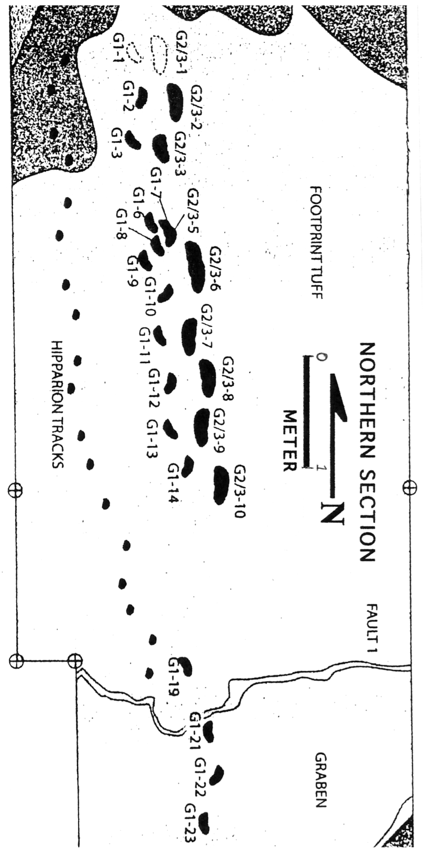
NORTHERN TRACKWAY
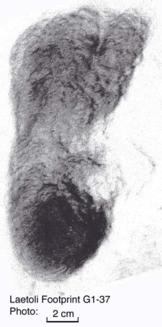

FOOTSTEPS IN TIME DATA SHEET

NAME | FOOT LENGTH | HEIGHT

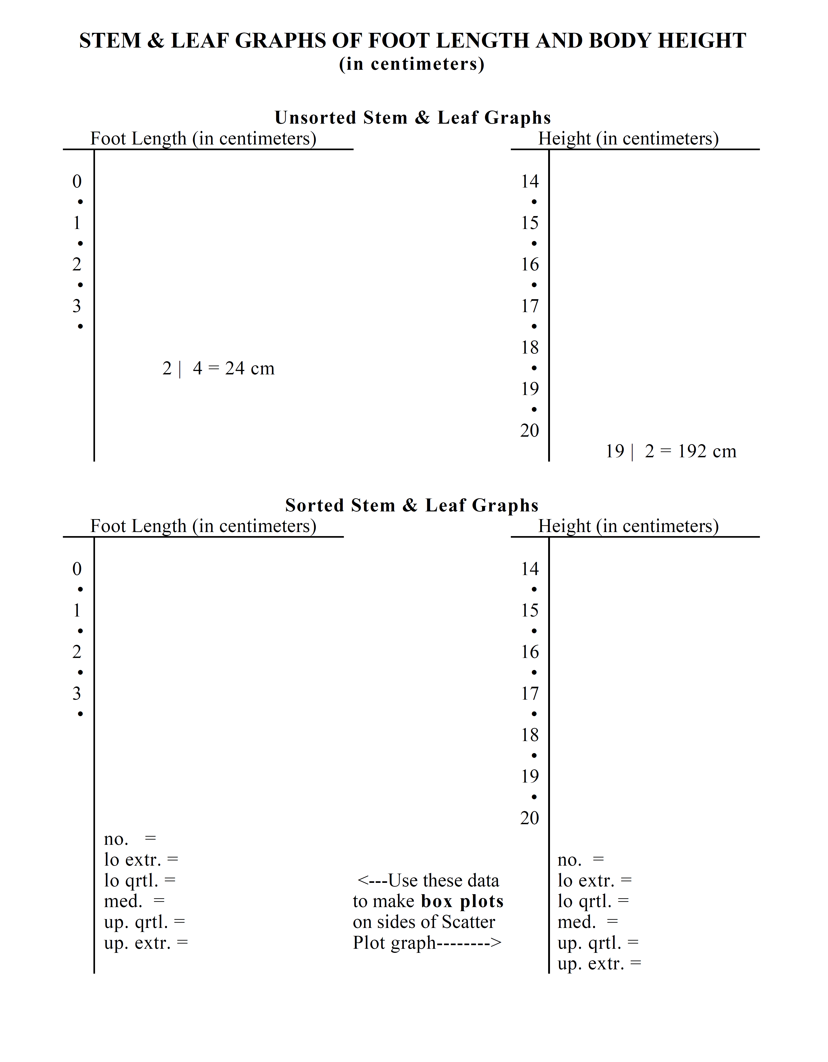

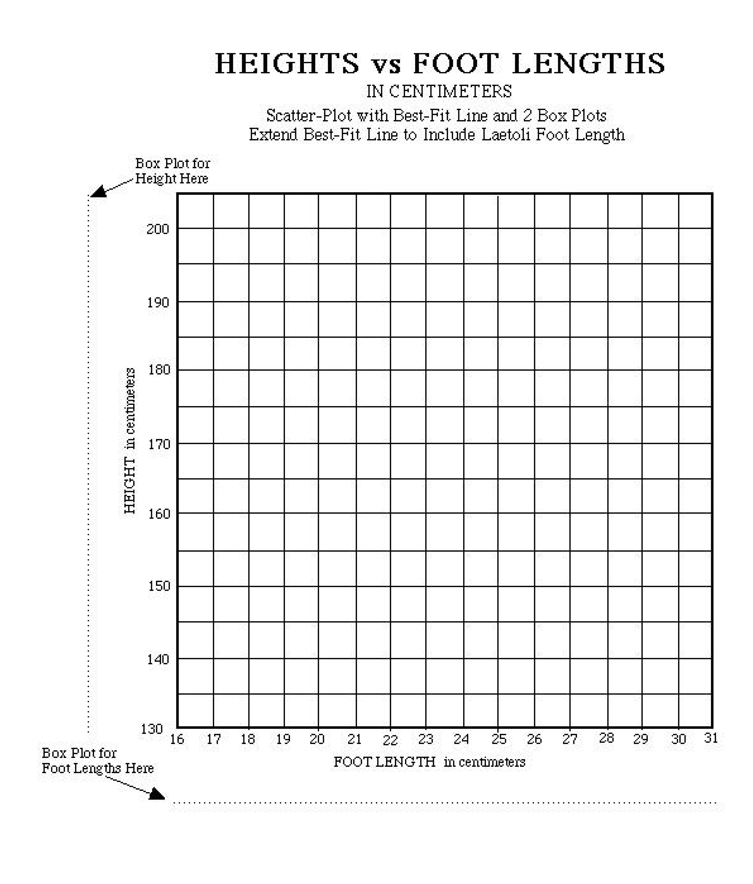

INFORMATION PROCESSING SHEET
NAME____________________________ PARTNERS_______________________________________

TOPIC TITLE_____________________________________________________________________

Learning Objective addressed: _____________________________________________________

Summary of Information and/or Data: (Must be a paragraph of at least three sentences. Tell what you LEARNED, NOT what you did.

Rate the likelihood that the Info-Data is accurate 1 2 3 4 5 6 7 8 9 10 Justify your rating:

Questions relating to the Info-Data: (Must be complete sentences and should not be obviously answered in the activity.)j
1.

2.

3.

Connections that link this Info-Data to OTHER Info-Data: (Only one connection can be linked to current studies. They must be about content, meaningful, and in complete sentences.)
1.

2.

Write a three sentence summary discussing how this activity supported the learning objective stated above.

EXPERIMENTAL WRITE-UP

TITLE:__________________________________________________________________________

I. QUESTION:__________________________________________________________________

II. PRIOR KNOWLEDGE AND ASSUMPTION: __________________________________________

_________________________________________________________________________________

_______________________________________________________________________________

III. Materials list and procedure:

IV. Hypothesis and Prediction:

V. Data Tables:

VI. Graphs and Statistical Analysis:

VII. Conclusion:

VII. New Question:

SAMPLE DATA AND RESULTS

SCIENCE AS WAY OF KNOWING
The Foundations of Modern Biology by JOHN A. MOORE
by the President and Fellows of Harvard College, 1993
ISBN 0-674-79480-X
Deduction 1: If the hypothesis of evolution is true, the species that lived in the remote past must be different from the species alive today.
Deduction 2: If the hypothesis of evolution is true, the older the sedimentary strata, the less the chance of finding fossils of contemporary species.
Deduction 3: If the hypothesis of evolution is true, then we would expect to find only the simplest organisms in the very oldest strata and the more complex ones in more recent strata.
Deductlon 4: If the hypothesis of evolution is true, it must be possible to demonstrate the slow change of one species into another.
Deduction 5: If the hypothesis of evolution is true, which assumes that all of today's species are the descendants of a few original forms, there should have been connecting forms between the major groups (phyla, classes, orders).
Deduction 6: If the hypothesis of evolution is true, the age of the earth must be very great, possibly millions of years old.
Deduction 7: There must be variation among organisms if the hypothesis of evolution is true.
Deduction 8: Natural selection can be operative only if more offspring are born than survive.
Deduction 9: If the hypothesis of evolution is true, there must be differences between the offspring that survive and reproduce and those that do not.
Deduction 10: If the hypothesis of evolution is true, only those variations that are inherited will be important.
Deduction 11: If the members of a taxonomic unit, such as the phylum chordata, share a common ancestry, that fact should be reflected in their structure.
Deduction 12: If the members of a taxonomic unit share a common ancestry, that fact should be reflected in their embryonic development.
Deduction 13: If evolutionary divergence is the basis of organic diversity, that fact should be reflected in the system of classification.
Deduction 14: If there is a unity of life based on descent from a common ancestor, this should be reflected in the structure of cells.
Deduction 15: If there is a unity of life based on evolution, that fact should be reflected in the molecular processes of organisms.
Give and evaluate evidence for the following deduction:

"Deduction 16: If the idea (hypothesis) of evolution is to be established as true, we must be able to obtain information on organisms that lived in the past."

